NEW JERSEY DEPARTMENT OF ENVIRONMENTAL PROTECTION
BUREAU OF PESTICIDE COMPLIANCE
401 EAST STATE STREET, MAIL CODE 401-04A, P.O. BOX 420, TRENTON, N.J. 08625-0420
www.pcpnj.org (609) 984-9568 BPO-07

MOSQUITO / FLY / ADULTICIDING / LARVICIDING PESTICIDE APPLICATION RECORD

Agency: Municipality:

AM AM
Date of Application: Actual Spray Time: (Start) PM (Stop) PM County:

Treatment
Location (s):

Method of Application: Target Pest: Mosquito Fly Adulticiding Larviciding

Air Temperature: (Start) (Stop) Wind Speed: (Start) (Stop)

Pesticide Used (Brand Name) Active Ingredient EPA Registration #

*Mixing Rate (Amount of Concentrate/Diluent) Total Amount of Pesticide Mixture Used

*The mixing Rate shall include the total amount of pesticide concentrate and the total amount of diluent used to mix the pesticides as required by the label.

Notification (N.J.A.C.7:30-9.10) Community or Area Wide Applications: Yes* No Not Applicable

*List 2 Local Newspapers: (Legal Ad) 1.

(Display Ad) 2.

Responsible Certified Applicator’s Name: License #

Pesticide Applicator/Operator Name (if applicable) License #

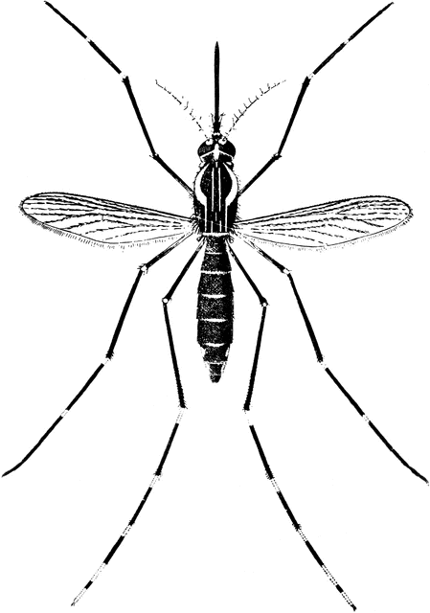
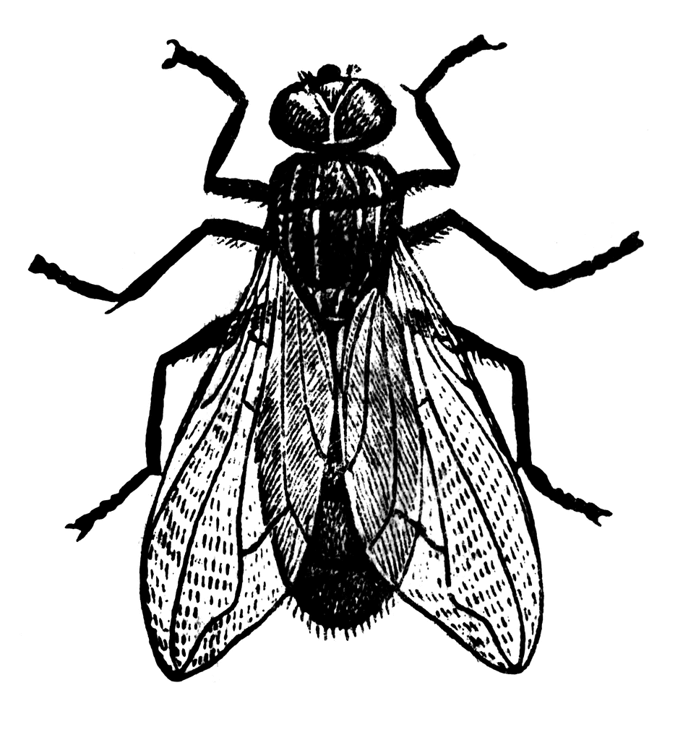
SUBMIT COPIES OF YOUR RECORDS WITHIN 3 WEEKS OF THE APPLICATION TO THE PESTICIDE CONTROL PROGRAM
DO NOT LEAVE ANY PART OF THIS FORM BLANK

